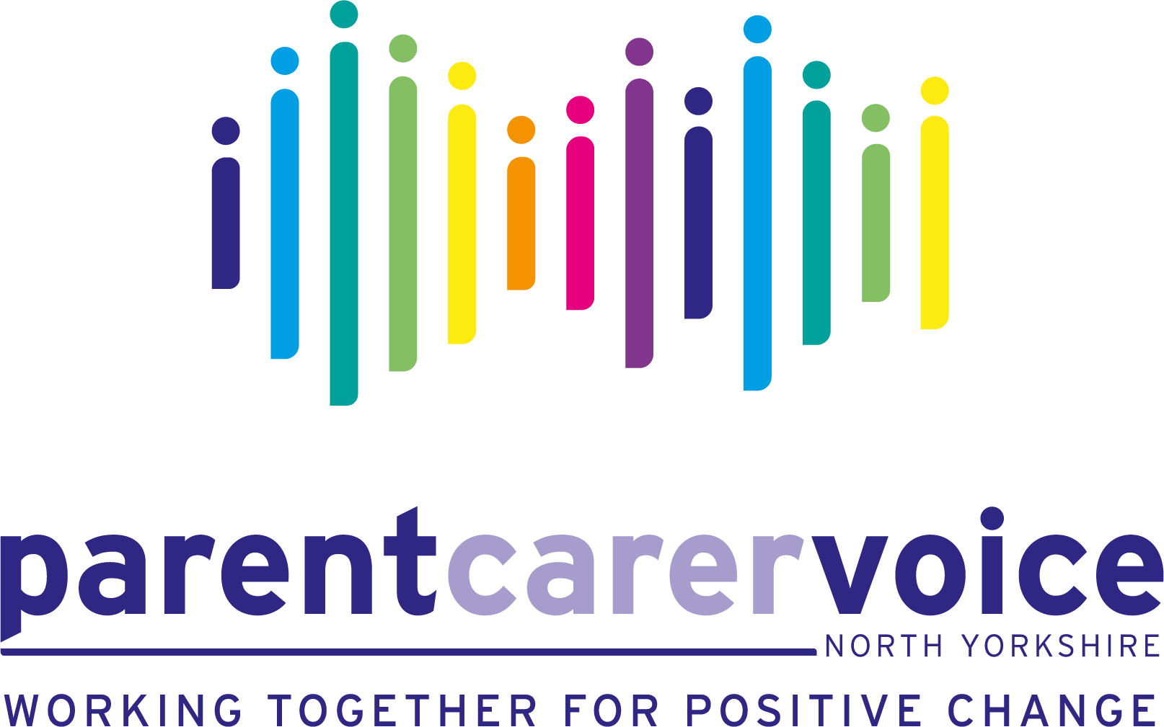

Dear Parents and Carers

**Partnerships for Inclusion of Neurodiversity in Schools (PINS) Programme**

We are writing to invite you to attend the upcoming parent carer support and information session **‘Social, Emotional and Mental Health - SEMH’**

In this session, we will be exploring social emotional and mental health. What it means, early warning signs to look out for, practical tips to support your child and signposting to services for further support.

The session will be taking place within Bainbridge school on **Tuesday 11th March** at 3.45pm. The session will last approximately 1.5 hours, with allocated time for questions and answers. The school has kindly offered to assist with childcare during the session.

We appreciate attending in person events can be tricky, the session will be hybrid which enables you to also join us online from wherever is most convenient for you. [Microsoft Teams link for 3.45pm hybrid session here](https://teams.microsoft.com/l/meetup-join/19%3ameeting_MWMxNzJhY2UtZThjYy00NmQ0LWFiZDMtZGRjNjM4ZTI4YThh%40thread.v2/0?context=%7b%22Tid%22%3a%22d2d6855f-0b54-4dc0-b73e-a355a6e84592%22%2c%22Oid%22%3a%22c534db1c-0b9e-49ef-97bc-5ba0abf83a0a%22%7d).

The session will also be repeated online on Thursday 13th March at 7.00pm [Microsoft Teams Link Here](https://teams.microsoft.com/l/meetup-join/19%3ameeting_YzFjN2JkNDAtMTkyMy00ZGFjLWE2MzktZjkwMTMzOWZkYzA2%40thread.v2/0?context=%7b%22Tid%22%3a%228f271912-37c3-40fc-98f7-509505a8d6c5%22%2c%22Oid%22%3a%2204609f0e-bf27-4079-9170-253a50651045%22%7d)

Just a gentle reminder -the project is for **all** children and young people that have an additional need**,** including but not limited to:

* Anxiety
* Dyslexia, Dysgraphia, Dyspraxia and Dyscalculia
* Developmental Language Disorder
* Foetal Alcohol Syndrome
* Autism
* Pathological Demand Avoidance
* Speech and language/communication needs
* Social and emotional needs
* ADHD/ADD
* Or any other form of developmental learning differences and needs…

More information on the PINS project can be found on our website here - <https://www.parentcarervoiceuk.org/news>

Thank you and we are really looking forward to visiting you in school again.

Parent Carer Voice North Yorkshire - Registered Charity: 1201947