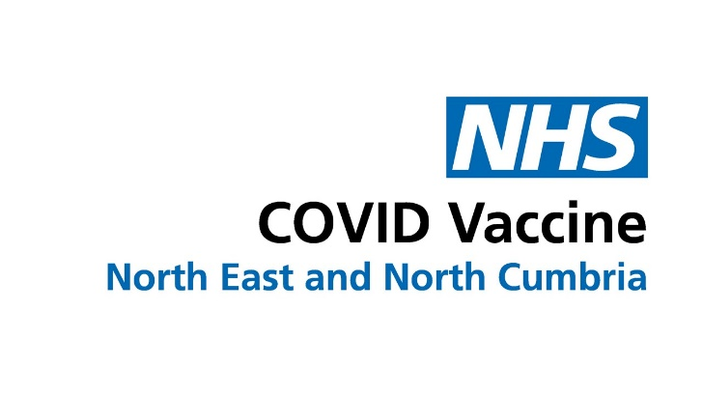

Information for schools
The COVID-19 vaccination programme in schools in partnership with the School Aged Immunisation Service (SAIS) is ending as we begin to administer the last of the vaccines ahead of the Easter holidays.
12 to 15-year-olds can also get their first or second dose outside of school by using the National Booking Service or one of the walk-in vaccination sites open to this age group.

Those who are more at risk from the virus or who live with someone who has a severely weakened immune system can get their second dose earlier, eight weeks after their first, and a further ‘booster’ dose from three months (91 days) after their second.

On 11 March, the National Booking Service opened to allow those at greatest risk from COVID, including those who are severely immunosuppressed and with underlying health conditions, to book their booster online.

Children in this age group who have had a severely weakened immune system can get a third primary dose from eight weeks after their second dose, then receive a booster from three months (91 days) later. These third primary doses for those eligible can make an appointment through local booking systems or get vaccinated through their local GP or hospital or home visit team as well as at some vaccination walk-in sites.

Vaccinating 5-11-year olds
On 16 February, the Government accepted advice from the JCVI to make a non-urgent offer of Covid-19 vaccines to all children aged five to 11, to increase protection against potential future waves of COVID-19.
The National Booking Service has opened and bookings for children aged 5 to 11 can now be made.

This will not be an in-school offer, except where SAIS providers are used to provide vaccinations in special educational needs (SEN) schools.

The number of clinics will increase towards Easter to support vaccination during school holidays when parents have more time.

The NHS is already vaccinating children aged 5 to 11 who are most at risk of Covid-19 or who are a household contact of someone who is immunosuppressed.

How to get an appointment
The National Booking Service (NBS) shows available appointments and there is also a site finder to locate vaccine walk-in centres which is updated regularly. This finder shows which doses are offered at each location and to which age groups.

